SAFI INSTITUTE OF ADVANCED STUDY(AUTONOMOUS)
Affiliated to University of Calicut, Accredited by NAAC with A++ Grade (3.54)
Recognized by UGC under 2(f),ISO 9001-2015 Certified by AAB
Vazhayoor East, Malappuram Dist, Kerala– 673633



Department of Computer Applications

Project Report
RenalGuide-Dialysis Center Management System

Done by,
- AFRA MUJEEB RAHMAN - (SIASBCA001)
- AMINA THANHA - (SIASBCA003)
- NIHA SUHAIL - (SIASBCA013)
- NIYA SILNA - (SIASBCA014)
Under the Guidance of,
RASHEEJA A.P
2023 - 2026
SAFI INSTITUTE OF ADVANCED STUDY(AUTONOMOUS)
Affiliated to University of Calicut, Accredited by NAAC with A++ Grade (3.54)
Recognized by UGC under 2(f),ISO 9001-2015 Certified by AAB
Vazhayoor East, Malappuram Dist, Kerala– 673633


Department of Computer Applications
CERTIFICATE
Certified that this is the bonafide report on the project work entitled

Done By
- AFRA MUJEEB RAHMAN - (SIASBCA001)
- AMINA THANHA - (SIASBCA003)
- NIHA SUHAIL - (SIASBCA013)
- NIYA SILNA - (SIASBCA014)

During the academic year 2023-2026 in partial fulfilment of requirement for the award of the degree of,
Bachelor of Computer Applications
Of
University of Calicut, Malappuram Dist., Kerala

Internal Guide Head of the Department

Internal Examiner External Examiner
COMPANY CERTIFICATE

ACKNOWLEDGEMENT

First and foremost, we express our deepest gratitude to the Almighty God for His abundant blessings, guidance, and grace that have illuminated our path and granted us strength and resilience throughout our academic pursuits.

We are immensely grateful to the Principal, Prof. E. P. Imbichi Koya, for his visionary leadership, unwavering support, and commitment to fostering an environment of excellence and innovation within our institute.

Our sincere thanks go to the Head of the Department, Mr. Abdul Samad C., for his invaluable guidance and encouragement, which have been instrumental in nurturing our intellectual curiosity and facilitating our academic growth.

We extend our heartfelt appreciation to our Project Guide, Mrs.Rasheeja A.P, whose guidance and support have been invaluable throughout the completion of this project.

We sincerely thank ________________. for providing practical exposure. We also extend our gratitude to our teachers, families, and friends for their continuous encouragement and support throughout this journey.

Student/s Name and Signatures

TABLE OF CONTENTS

1.ABSTRACT
2: INTRODUCTION.............................................. 6
2.1 Problem Statement ....................................................7
2.2 Project Motivation ................................................... 7
2.3 Objectives of the Project ...........................................8
2.4 Scope of the Project ................................................. 8

3: SYSTEM ANALYSIS.........................................13
3.1 Existing System..................................................... 14
3.2 Problems and Limitations of Existing System ......... 15
3.3 Proposed System..................................................... 14
3.4 Feasibility Study ................................................... 16
3.4.1 Technical Feasibility............................. 16
3.4.2 Operational Feasibility ........................... 16
3.4.3 Economic Feasibility ............................... 16

4: SYSTEM DESIGN ............................................. 23
4.1 System Architecture Diagram .....................................23
4.2 Data Flow Diagrams ...........................................24
4.3 Use Case Diagram ...........................................24

5: IMPLEMENTATION............................................ 33
5.1 Tools, Languages, and Frameworks ...............................33
5.2 Code Explanation..................................................... 34
5.3 Frontend / Backend / UI Implementation ......................35
5.4 Model Logic ............................................. 36

6: TESTING AND VALIDATION .................................. 34
6.1 Unit Testing .................................................... 34
6.2 System Testing........................................ 35
6.3 Integration Testing ................................................. 37

7: GUI SCREENSHOTS................................... 38

8: RESULTS AND DISCUSSION.......................................40
8.1 Observations .................................................... 34
8.2 Limitations....................................... 35

9: FUTURE ENHANCEMENTS .............................. 41
10: CONCLUSION ..............................
11: APPENDIX......................
A. Source Code........................................................... 43

ABSTRACT
The healthcare domain has witnessed significant advancements with the integration of Artificial Intelligence (AI) and web-based technologies, particularly in patient care management. This project falls under the Web Development and Healthcare domain, focusing on improving the care and management of dialysis patients. Dialysis patients require complex, routine care, including monitoring of health parameters, scheduling of dialysis sessions, and adherence to diet and treatment plans. Traditional methods rely heavily on manual tracking by caregivers and staff, which can be time-consuming and prone to errors. The primary problem addressed in this project is the lack of an efficient and centralized system to manage patient records, dialysis sessions, appointments, and prescriptions, while providing personalized support such as AI-based diet recommendations.
To solve this problem, a web and mobile platform is developed. The mobile application (Flutter) allows caretakers to add/manage patients, record health parameters, book dialysis appointments and slots, view prescriptions, and communicate with doctors. Staff can record dialysis session counts and update patient parameters. The web application enables admins to manage caretakers, doctors, staff, and dialysis time slots; monitor appointments and doctor availability; and handle patient requests. Doctors can prescribe medications, track dialysis appointments, update availability, and access patient records and health parameters. The system emphasizes secure data handling, dialysis-specific functionalities, and intuitive user interfaces.
The project utilizes tools and technologies such as Flutter for mobile development, Django for web development, and SQL/SQLite for database management. AI techniques are employed to generate personalized diet plans for patients. The system improves patient engagement and treatment adherence, enhances coordination among patients, caregivers, and doctors, and ultimately supports better health outcomes and quality of life for dialysis patients.

INTRODUCTION
CHAPTER 2

INTRODUCTION

2.1 Problem Statement
Dialysis patients require continuous monitoring of health parameters, timely dialysis sessions, and adherence to diet and treatment plans. Traditional management relies on manual tracking by caregivers, staff, and doctors, which is often time-consuming, error-prone, and inefficient. There is no centralized system to manage patient records, dialysis schedules, doctor appointments, prescriptions, and caregiver communication in one platform. Additionally, patients often lack personalized diet guidance, which is crucial for preventing dialysis-related complications. This project addresses the need for an automated, secure, and user-friendly system that streamlines dialysis care, improves coordination among patients, caregivers, and healthcare providers, and provides AI-based personalized diet recommendations to enhance patient adherence and health outcomes.

2.2 Project Motivation

The motivation for this project stems from the challenges faced by dialysis patients, caregivers, and healthcare providers in managing complex treatment routines. Dialysis requires strict adherence to schedules, monitoring of health parameters, and maintenance of a suitable diet, which is difficult to track manually. Caregivers and medical staff often struggle with coordinating appointments, managing patient records, and ensuring timely treatment. This project is motivated by the need to streamline dialysis care, reduce manual effort, minimize errors, and provide personalized support through AI-based diet recommendations, ultimately improving patient adherence, coordination among stakeholders, and the overall quality of life for dialysis patients.

2.3 Objectives of the Project

The primary objectives of this project are to develop a centralized web and mobile platform for efficient management of dialysis patients, caregivers, staff, and doctors, enable real-time scheduling and tracking of dialysis appointments and sessions, allow doctors to access patient records, monitor health parameters, prescribe medications, and update availability, provide caretakers and staff the ability to record patient health data and dialysis session counts, facilitate effective communication between patients, caregivers, and doctors, implement AI-based personalized diet recommendations to support patient nutrition and treatment adherence, ensure secure data handling and intuitive user interfaces, and ultimately improve coordination, treatment adherence, and overall quality of life for dialysis patients.

2.4 Scope of the Project
The scope of this project includes the development of a comprehensive web and mobile platform for managing dialysis patient care, covering features such as patient registration, health parameter tracking, dialysis session and appointment scheduling, prescription management, and communication between patients, caregivers, and doctors. The system also incorporates AI-based personalized diet recommendations to support patient nutrition and treatment adherence. It is designed for secure data handling, real-time monitoring, and intuitive user interfaces, aiming to streamline healthcare workflows, improve coordination among stakeholders, enhance patient engagement, and ultimately contribute to better health outcomes and quality of life for dialysis patients.

SYSTEM ANALYSIS
CHAPTER 3

3.1 Existing system

In the existing system, dialysis patient management is primarily handled through manual and semi-digital methods. Patient health records, dialysis schedules, prescriptions, and appointment details are often maintained in paper files or basic software such as spreadsheets. Communication between patients, caregivers, staff, and doctors is mostly done through phone calls or in-person interactions, which can lead to delays, miscommunication, and data loss.Monitoring of patient parameters and dialysis sessions depends heavily on caregivers and staff, making the process time-consuming and prone to human errors. There is no centralized platform to integrate patient records, scheduling, treatment history, and caregiver coordination. Additionally, diet planning for dialysis patients is usually generic and not personalized, requiring patients to rely on manual advice from doctors or dieticians. This lack of automation, integration, and personalization reduces efficiency and affects the quality of patient care.

3.2 Problems and limitation of existing system

- Manual Record Management
Patient records, dialysis details, and prescriptions are often maintained manually or across multiple systems, increasing the risk of data loss, duplication, and errors.
- Lack of Centralized System
There is no single platform to manage patient information, dialysis schedules, appointments, and treatment history, leading to poor coordination among patients, caregivers, staff, and doctors.
- Time-Consuming Processes
Scheduling dialysis sessions, tracking patient parameters, and updating records require significant manual effort, resulting in delays and inefficiency in healthcare delivery.
- Poor Communication
Communication between patients, caregivers, and healthcare providers relies on calls or in-person updates, which can cause miscommunication and missed appointments.
- Error-Prone Monitoring
Manual monitoring of health parameters and dialysis sessions increases the chances of human error, which may negatively impact patient safety.
- Lack of Personalized Diet Planning
Existing systems do not provide AI-based or personalized diet recommendations, forcing patients to follow generic diet plans that may not suit their individual health needs.
- Limited Data Security
Paper-based and basic digital systems lack proper security measures, making patient data vulnerable to unauthorized access or loss.
- Poor Patient Engagement
Patients have limited access to their own health data, reducing awareness, adherence to treatment plans, and overall involvement in their care.

3.3 Proposed system

The proposed system is a centralized web and mobile-based application designed to efficiently manage dialysis patient care. It integrates patients, caregivers, staff, and doctors into a single platform to ensure seamless coordination and data sharing. The system enables real-time scheduling and tracking of dialysis appointments and sessions, reducing manual effort and scheduling errors.
Doctors can securely access complete patient records, monitor health parameters, prescribe medications, and update their availability through the system. Caregivers and staff are provided with user-friendly interfaces to record patient health data, dialysis session counts, and daily observations accurately.
The system also facilitates effective communication between patients, caregivers, and healthcare providers through notifications and updates. An AI-based personalized diet recommendation module supports patient nutrition and treatment adherence by suggesting diet plans based on individual health parameters.
Strong security measures are implemented to protect sensitive medical data, and the intuitive design ensures ease of use for all users. Overall, the proposed system improves coordination, enhances treatment adherence, reduces errors, and significantly improves the quality of care and quality of life for dialysis patients.

3.4 Feasibility Study

A feasibility study is conducted to evaluate the practicality and viability of developing the proposed Dialysis Patient Management System. The study analyzes the project from technical, economic, operational, and schedule perspectives to ensure successful implementation.

3.4.1 Technical Feasibility

The project is technically feasible as it uses well-established and widely supported technologies. The system is developed using Flutter for the mobile application, Django for the web application, and SQL/SQLite for database management. These technologies are open-source, scalable, and suitable for healthcare applications. Flutter enables cross-platform mobile development, while Django provides a secure and robust backend framework. AI-based diet recommendation techniques can be implemented using rule-based logic or basic machine learning models, which are feasible with available libraries and tools. The required hardware and software resources are readily available, and the development team can implement the system without the need for specialized or expensive infrastructure.

3.4.2 Economic Feasibility

The project is economically feasible since it primarily relies on open-source technologies, minimizing development and licensing costs. There is no requirement for costly proprietary software or hardware. Development, deployment, and maintenance costs are relatively low compared to the benefits offered by the system. By reducing manual effort, paperwork, and errors in dialysis care management, the system can help healthcare providers save time and operational costs. The long-term benefits, such as improved efficiency, better patient outcomes, and reduced administrative burden, outweigh the initial development expenses.

3.4.3 Operational Feasibility

The project is operationally feasible as it is designed with user-friendly and intuitive interfaces for all stakeholders, including patients, caregivers, staff, doctors, and administrators. The system simplifies routine tasks such as scheduling dialysis sessions, recording health parameters, managing prescriptions, and communicating between users. Since the system automates many manual processes, it reduces workload and improves coordination among healthcare providers. Minimal training is required for users to adapt to the system, making it suitable for real-world healthcare environments.

SYSTEM DESIGN
CHAPTER 4

4.1 System Architecture Diagram
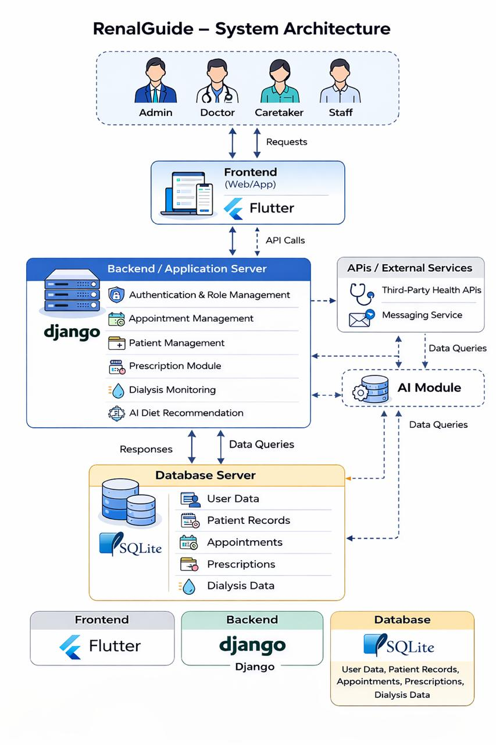

4.2 Data Flow Diagrams
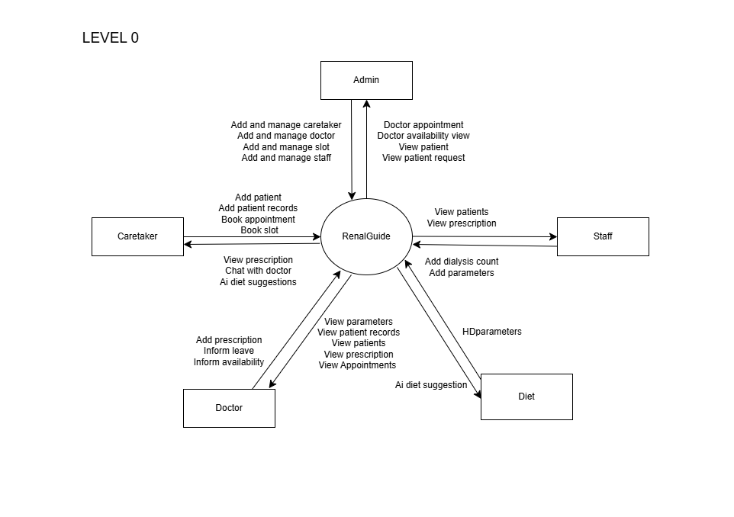

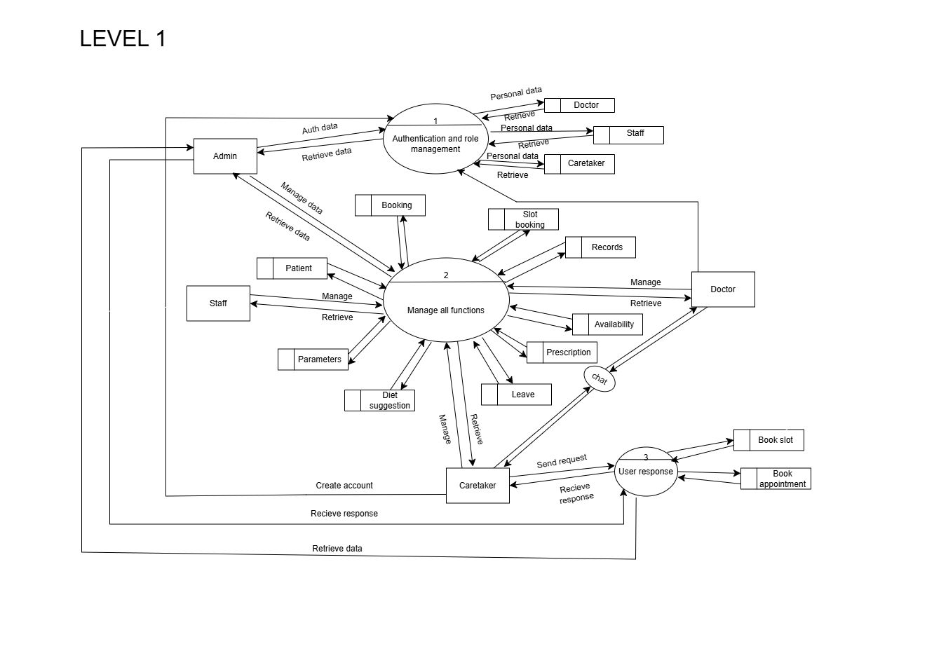
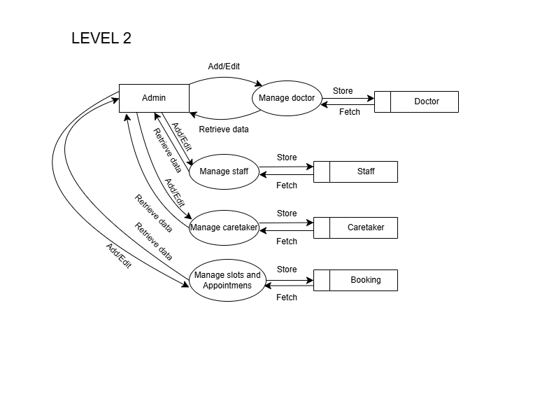

4.3 Use Case Diagram
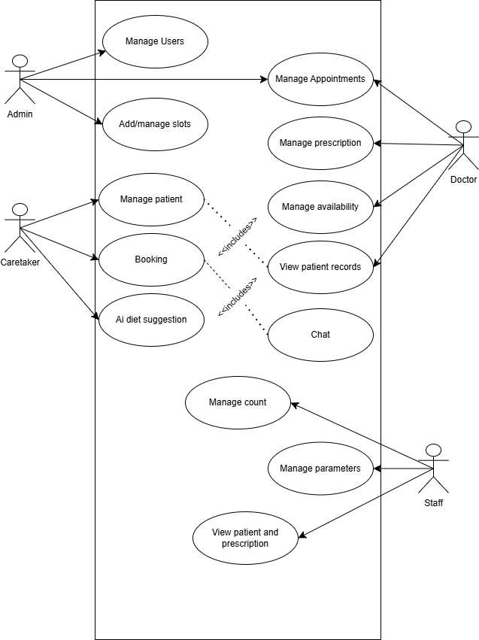

IMPLEMENTATION
CHAPTER 5

5.1 Tools, Languages, and Frameworks
The RenalGuide system is developed using a combination of modern tools, programming languages, and frameworks to ensure efficiency, scalability, and ease of use. Python is used as the primary backend programming language due to its simplicity, readability, and strong support for web development. The Django framework is employed to build a secure and robust backend, providing features such as user authentication, database management, and RESTful APIs. SQLite is used as the database system for storing patient records, appointments, prescriptions, and other medical data, as it is lightweight and suitable for small to medium-scale applications. For the frontend, Flutter is used to develop a cross-platform mobile application, enabling a consistent user interface and smooth performance across both Android and iOS devices. Together, these technologies provide a reliable and efficient platform for managing dialysis patient care.
5.2 Code Explanation
The Renal Guide project follows a modular and layered code structure to ensure clarity, security, and ease of maintenance. The frontend is developed using Flutter and Dart, where different screens are designed for doctors, staff, patients, and caretakers. These screens include forms and dashboards that allow users to enter, view, and manage dialysis-related information. The frontend communicates with the backend through RESTful API calls to send requests and receive responses.
The backend is implemented using Django and Django REST Framework, which handle the core application logic. Django models define the database structure for entities such as patients, appointments, dialysis sessions, prescriptions, and medical records, while views and serializers manage data validation and API responses. Django ORM is used for efficient database interaction without writing complex SQL queries. This structured approach ensures smooth data flow, secure handling of medical information, and reliable execution of the Renal Guide system.
5.3 Frontend/backend/UI
The Renal Guide Dialysis Management System is developed using a structured client–server architecture that clearly separates the frontend, backend, and user interface. The frontend is built using Flutter and Dart, providing role-based screens for doctors, staff, patients, and caretakers. It allows users to perform actions such as managing appointments, recording dialysis parameters, viewing prescriptions, and accessing patient medical records, while communicating with the backend through RESTful APIs.
The backend is implemented using Django and Django REST Framework, which manage application logic, user authentication, role-based access control, and secure data processing. It handles the storage and retrieval of patient details, dialysis session logs, prescriptions, appointments, and medical records using a relational database. The User Interface (UI) is designed with Flutter Material UI components, ensuring a clean, responsive, and easy-to-use design that supports efficient navigation and accurate data entry for all user roles.
5.4 AI Model Logic
In the Renal Guide system, the AI-based diet suggestion feature is implemented using an external artificial intelligence service accessed through the OpenRouter API. This feature provides diet recommendations for dialysis patients based on their medical data.
The process begins by collecting laboratory values of the patient from the database, such as blood test results relevant to renal health. These laboratory values are formatted into a structured prompt and securely transmitted to the AI model through the OpenRouter API using an API key.
The AI service analyzes the provided laboratory data and generates appropriate diet suggestions tailored to the patient’s renal condition. The generated output includes recommended foods, restricted items, and dietary guidelines suitable for dialysis patients. The backend then processes and formats the response before delivering it to the frontend, where it is displayed in a clear and user-friendly manner.
This approach ensures accurate, scalable, and efficient generation of personalized diet recommendations while maintaining seamless integration within the Renal Guide system.

TESTING AND VALIDATION
CHAPTER 6

6.1 Unit Testing
Unit testing in the Renal Guide Dialysis Management System is carried out to verify the correct functioning of individual modules in isolation before system integration. The testing process mainly focuses on backend components developed using Django, as they contain critical business logic and data handling operations. Each unit, including user authentication, patient management, appointment scheduling, dialysis session recording, prescription handling, and medical record uploads, is tested using Django’s built-in testing framework with a separate test database. Unit tests validate data accuracy, role-based access control, input validation, and error handling under both valid and invalid conditions. This approach helps in early detection of defects, improves code reliability, ensures secure handling of sensitive medical data, and enhances the overall stability and maintainability of the Renal Guide system.
6.2 System Testing
System testing for the Renal Guide Dialysis Management System is performed to evaluate the complete and fully integrated application to ensure that it meets the specified functional and non-functional requirements. In this phase, all modules—including user authentication, role-based dashboards, patient management, appointment and dialysis scheduling, prescription handling, medical record uploads, and communication between doctors, staff, patients, and caretakers—are tested together as a single system. The testing verifies end-to-end workflows, data consistency between the Flutter frontend and the Django backend through REST APIs, proper database updates, and correct role-based access control. System testing also checks usability, performance, error handling, and security to confirm that the application functions reliably under real-world conditions and delivers a stable, accurate, and user-friendly dialysis management solution.
6.3 Integration Testing
Integration testing in the Renal Guide Dialysis Management System is conducted to verify the correct interaction and data flow between different modules after unit testing is completed. This testing phase ensures that the frontend developed using Flutter integrates seamlessly with the backend implemented using Django and Django REST Framework through RESTful APIs. Key integrations tested include user authentication with role-based dashboards, patient and doctor data synchronization, appointment booking linked with dialysis scheduling, prescription updates reflected across patient and caretaker views, and medical record uploads stored and retrieved correctly from the database. Integration testing validates that data passed between modules is accurate, consistent, and secure, and that combined components function together without errors, thereby ensuring smooth system operation before system testing and deployment.

GUI SCREENSHOTS
CHAPTER 7

7.1.1 Admin and doctor login page
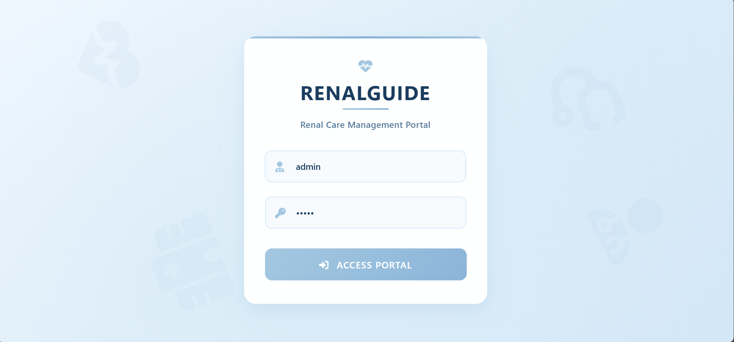
7.1.2 Admin Homepage
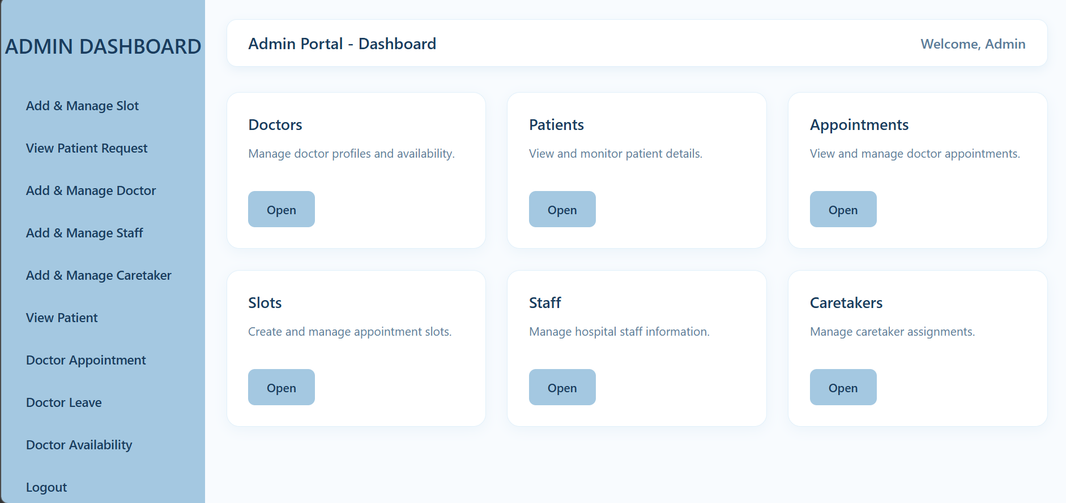

7.1.3 Doctor Homepage
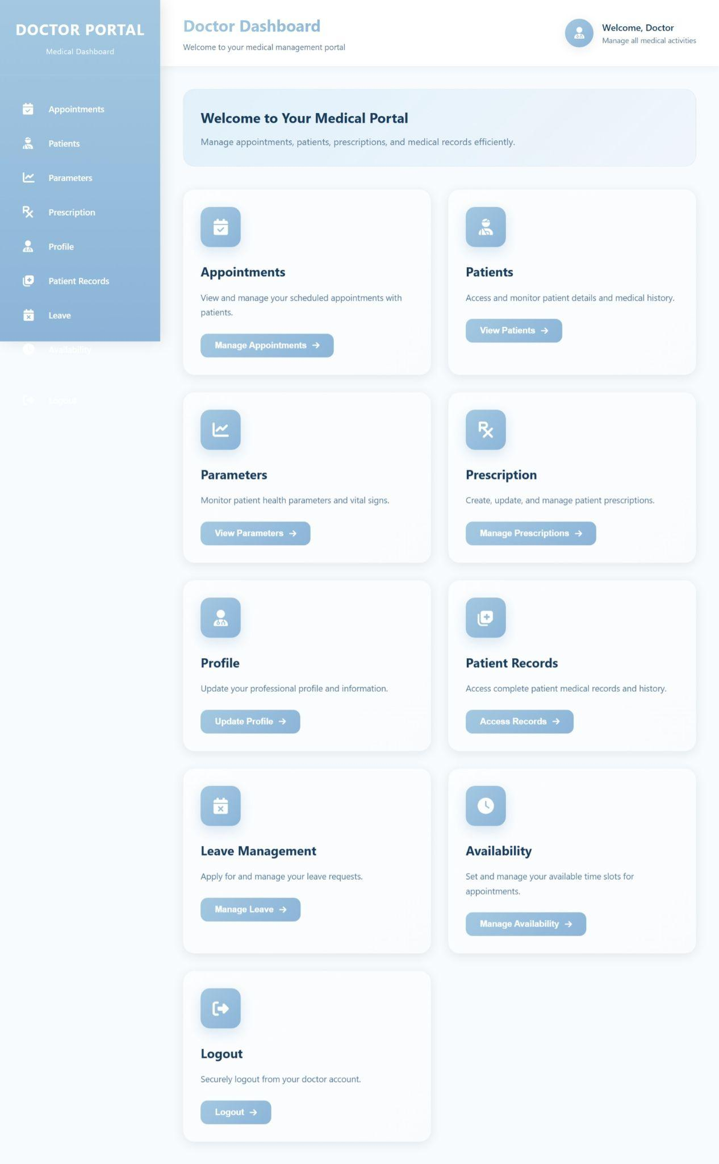
7.1.4 Caretaker and Staff Login Page
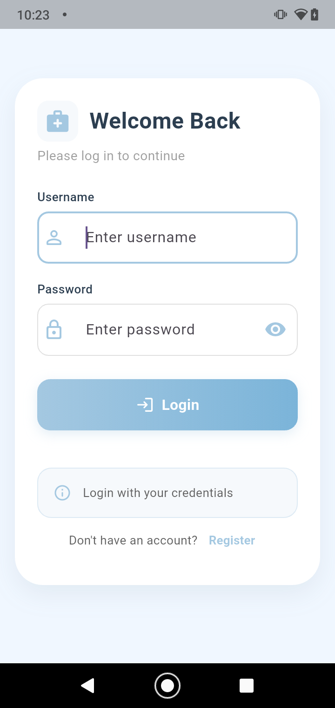

7.1.4 Caretaker Registration
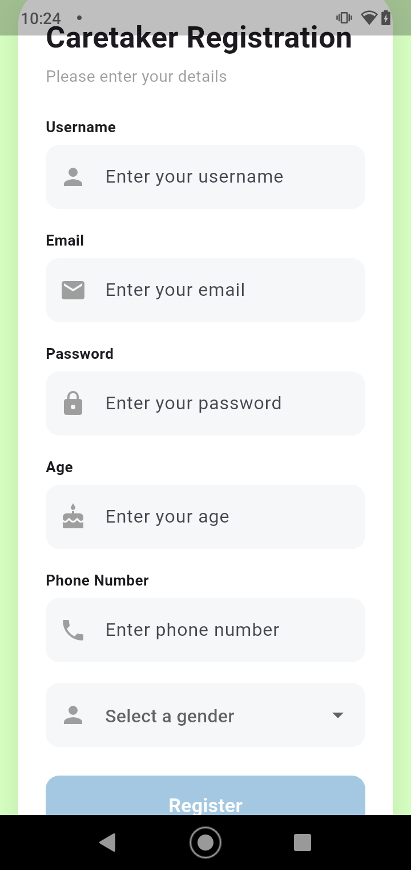

7.1.5 Caretaker Homepage
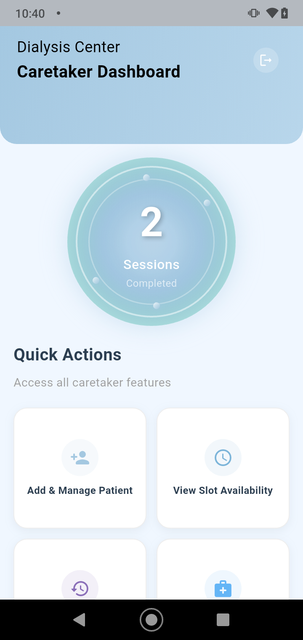

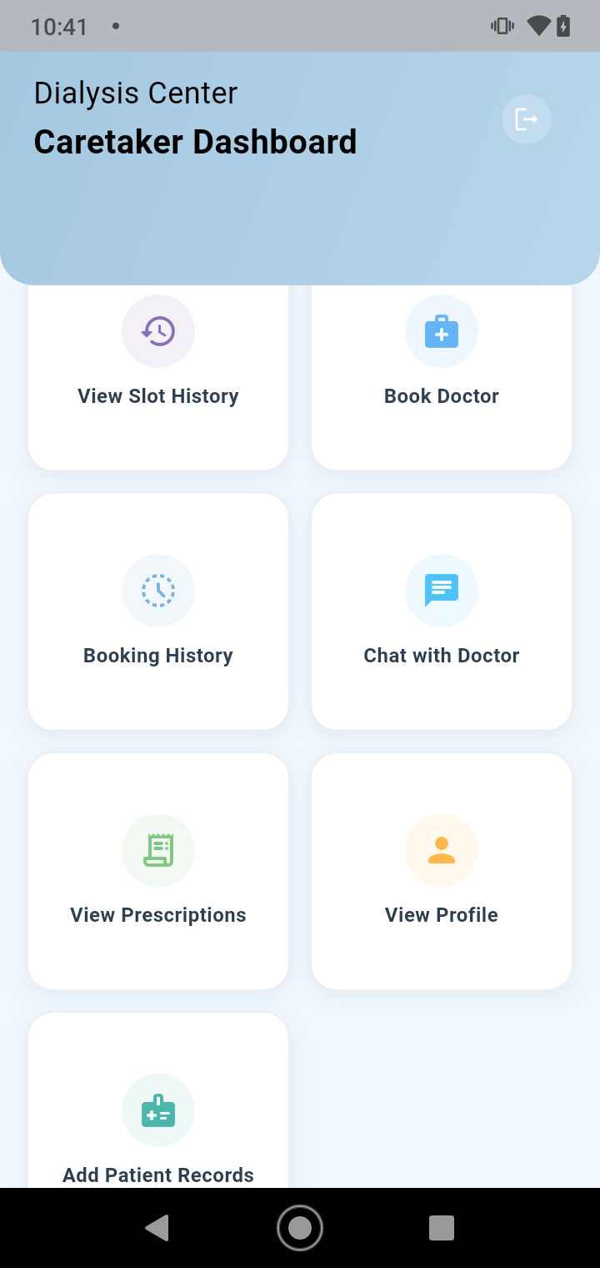

RESULTS AND DISCUSSION
CHAPTER 8

8.1 Observations
In the Renal Guide system, several meaningful observations and patterns were identified through the analysis of patient laboratory values and system usage. It was observed that changes in laboratory parameters such as potassium, phosphorus, creatinine, and hemoglobin had a direct impact on the dietary guidance provided to patients. Abnormal values consistently required specific food restrictions or recommendations, emphasizing the importance of lab-based diet planning for dialysis patients. Regular and updated laboratory data resulted in more accurate and condition-specific diet suggestions.
From a system usage perspective, a clear role-based interaction pattern was observed. Doctors and medical staff primarily focused on entering and updating laboratory values and clinical data, while patients and caretakers mainly accessed diet suggestions, prescriptions, and medical records. These observations demonstrate that integrating laboratory values with intelligent diet guidance improves personalized care, supports clinical decision-making, and enhances patient awareness and adherence to renal dietary guidelines.
8.2 Limitations
Despite its advantages, the Renal Guide system has certain limitations and challenges. The accuracy of AI-based diet suggestions depends entirely on the correctness and timeliness of laboratory values entered into the system; outdated or incomplete lab data may lead to less relevant recommendations. The system relies on continuous internet connectivity for communication between the Flutter frontend, Django backend, and the AI service, which may limit usability in areas with poor network access.
Additionally, the diet recommendation feature provides general guidance and does not replace professional medical or dietitian consultation. The system currently supports limited customization based only on laboratory values and does not consider other factors such as patient preferences or lifestyle. Data privacy and security remain critical concerns due to the handling of sensitive medical information, requiring strict access control and secure API usage. These limitations highlight areas for future enhancement and system improvement.

FUTURE ENHANCEMENTS
CHAPTER 9

9.1 Future Enhancements
Future enhancements of the Renal Guide Dialysis Management System can focus on expanding system features and improving overall usability. Advanced functionalities such as real-time alerts for abnormal laboratory values, automated reminders for dialysis sessions, medications, and follow-up appointments can be introduced to support timely medical intervention. Enhanced reporting and visualization dashboards for doctors and administrators can further assist in monitoring patient progress and making informed clinical decisions.
To support wider adoption, the system can be scaled to handle larger datasets and real-time data processing by optimizing backend performance and using more robust database solutions. Cloud integration can improve system availability, reliability, and data backup, while enabling centralized access for multiple hospitals or dialysis centers. Additional mobile enhancements, including support for multiple platforms and offline data synchronization, can increase accessibility, especially in remote areas.
The AI-based diet suggestion module can also be improved by incorporating richer and more comprehensive datasets, including historical laboratory trends and broader nutritional information. Refining AI interaction logic and response validation can enhance the accuracy and relevance of dietary recommendations. These enhancements will make the Renal Guide system more intelligent, scalable, and effective in supporting dialysis patient care.

CONCLUSION
CHAPTER 10

10.1 Conclusion
The Renal Guide project successfully addresses the problem of inefficient and fragmented management of dialysis patients by providing a centralized digital platform for handling patient records, dialysis sessions, laboratory values, prescriptions, and diet guidance. By integrating role-based access for doctors, staff, patients, and caretakers, the system improves coordination, reduces manual errors, and ensures timely access to critical medical information. The inclusion of AI-assisted diet suggestions based on laboratory values further supports personalized renal care and patient awareness.
Through the development of this project, key learnings were gained in full-stack application development, including frontend design using Flutter, backend implementation with Django and REST APIs, database management, and secure handling of sensitive healthcare data. The project also provided practical experience in system testing, integration testing, and working with external AI services through APIs. These technical and academic learnings strengthened understanding of real-world healthcare software challenges and solution design.
From a social and technical perspective, Renal Guide offers value by improving the quality of dialysis patient management and supporting better clinical decision-making through organized data and intelligent guidance. Academically, the project demonstrates the effective application of modern software technologies in healthcare. In conclusion, Renal Guide represents a scalable and meaningful solution that can be further enhanced to support broader adoption and contribute positively to digital healthcare management systems.

APPENDIX
CHAPTER 11

- Full source code
11.1.1 Login page
{% load static %}

<html lang="en">
<head>
<meta charset="UTF-8">
<meta name="viewport" content="width=device-width, initial-scale=1.0">
<title>RenalGuide - Login</title>

<style>
* {
margin: 0;
padding: 0;
box-sizing: border-box;
}

body {
font-family: 'Segoe UI', Tahoma, Geneva, Verdana, sans-serif;
background: linear-gradient(135deg, #f0f8ff 0%, #e1f0fa 50%, #d4e7f7 100%);
min-height: 100vh;
display: flex;
justify-content: center;
align-items: center;
padding: 20px;
position: relative;
overflow: hidden;
}

/* Background pattern overlay */
body::before {
content: '';
position: absolute;
top: 0;
left: 0;
right: 0;
bottom: 0;
background-image:
radial-gradient(circle at 20% 80%, rgba(164, 200, 225, 0.1) 0%, transparent 50%),
radial-gradient(circle at 80% 20%, rgba(164, 200, 225, 0.08) 0%, transparent 50%),
radial-gradient(circle at 40% 40%, rgba(164, 200, 225, 0.05) 0%, transparent 50%);
z-index: -1;
}

/* Medical themed floating elements */
.floating-icon {
position: absolute;
color: rgba(164, 200, 225, 0.1);
font-size: 120px;
z-index: -1;
animation: float 20s infinite linear;
}

.icon-1 {
top: 10%;
left: 10%;
animation-delay: 0s;
}

.icon-2 {
top: 20%;
right: 15%;
animation-delay: -5s;
}

.icon-3 {
bottom: 15%;
left: 20%;
animation-delay: -10s;
}

.icon-4 {
bottom: 25%;
right: 10%;
animation-delay: -15s;
}

@keyframes float {
0%, 100% {
transform: translateY(0) rotate(0deg);
}
25% {
transform: translateY(-20px) rotate(90deg);
}
50% {
transform: translateY(0) rotate(180deg);
}
75% {
transform: translateY(20px) rotate(270deg);
}
}

.login-container {
width: 100%;
max-width: 420px;
background: rgba(255, 255, 255, 0.98);
padding: 40px 35px;
border-radius: 20px;
box-shadow:
0 15px 35px rgba(164, 200, 225, 0.25),
0 5px 15px rgba(164, 200, 225, 0.1),
inset 0 1px 0 rgba(255, 255, 255, 0.8);
backdrop-filter: blur(10px);
border: 1px solid rgba(255, 255, 255, 0.3);
position: relative;
overflow: hidden;
transition: transform 0.3s ease, box-shadow 0.3s ease;
}

.login-container::before {
content: '';
position: absolute;
top: 0;
left: 0;
right: 0;
height: 4px;
background: linear-gradient(90deg, #A4C8E1 0%, #8bb4d8 50%, #A4C8E1 100%);
border-radius: 20px 20px 0 0;
}

.login-container:hover {
transform: translateY(-5px);
box-shadow:
0 20px 40px rgba(164, 200, 225, 0.35),
0 8px 20px rgba(164, 200, 225, 0.15),
inset 0 1px 0 rgba(255, 255, 255, 0.8);
}

.logo {
text-align: center;
margin-bottom: 35px;
}

.logo h1 {
color: #1a3c5e;
font-size: 34px;
font-weight: 700;
letter-spacing: 1.5px;
margin-bottom: 8px;
position: relative;
display: inline-block;
}

.logo h1::after {
content: '';
position: absolute;
bottom: -8px;
left: 50%;
transform: translateX(-50%);
width: 80px;
height: 3px;
background: linear-gradient(90deg, #A4C8E1 0%, #8bb4d8 100%);
border-radius: 2px;
}

.logo p {
color: #5a7c9a;
font-size: 15px;
font-weight: 500;
margin-top: 15px;
letter-spacing: 0.5px;
}

.medical-icon {
color: #A4C8E1;
font-size: 24px;
margin-bottom: 10px;
}

.input-group {
position: relative;
margin-bottom: 24px;
}

.input-group i {
position: absolute;
left: 18px;
top: 50%;
transform: translateY(-50%);
color: #A4C8E1;
font-size: 18px;
transition: color 0.3s ease;
}

input {
width: 100%;
padding: 16px 16px 16px 52px;
border: 2px solid #e1f0fa;
border-radius: 12px;
font-size: 15px;
font-weight: 500;
color: #1a3c5e;
background: #f8fbfe;
transition: all 0.3s ease;
font-family: 'Segoe UI', Tahoma, sans-serif;
}

input:focus {
outline: none;
border-color: #A4C8E1;
background: white;
box-shadow: 0 0 0 4px rgba(164, 200, 225, 0.2);
}

input:focus + i {
color: #8bb4d8;
}

input::placeholder {
color: #8bb4d8;
font-weight: 400;
}

.login-btn {
width: 100%;
padding: 17px;
background: linear-gradient(135deg, #A4C8E1 0%, #8bb4d8 100%);
color: white;
border: none;
border-radius: 12px;
font-size: 16px;
font-weight: 600;
cursor: pointer;
transition: all 0.3s ease;
letter-spacing: 1px;
text-transform: uppercase;
margin-top: 10px;
font-family: 'Segoe UI', Tahoma, sans-serif;
position: relative;
overflow: hidden;
}

.login-btn::before {
content: '';
position: absolute;
top: 0;
left: -100%;
width: 100%;
height: 100%;
background: linear-gradient(90deg, transparent, rgba(255, 255, 255, 0.2), transparent);
transition: left 0.5s ease;
}

.login-btn:hover {
background: linear-gradient(135deg, #8bb4d8 0%, #6fa0cc 100%);
box-shadow: 0 10px 25px rgba(164, 200, 225, 0.4);
transform: translateY(-2px);
}

.login-btn:hover::before {
left: 100%;
}

.login-btn:active {
transform: translateY(0);
}

.login-btn i {
margin-right: 8px;
}

.error-message {
background: linear-gradient(135deg, rgba(220, 53, 69, 0.1) 0%, rgba(220, 53, 69, 0.05) 100%);
color: #dc3545;
padding: 14px;
border-radius: 10px;
margin-bottom: 20px;
text-align: center;
font-size: 14px;
font-weight: 500;
display: none;
border-left: 4px solid #dc3545;
animation: shake 0.5s ease;
}

.error-message.show {
display: block;
}

@keyframes shake {
0%, 100% { transform: translateX(0); }
25% { transform: translateX(-5px); }
75% { transform: translateX(5px); }
}

.footer-text {
text-align: center;
margin-top: 30px;
padding-top: 20px;
border-top: 1px solid #e1f0fa;
color: #8bb4d8;
font-size: 13px;
line-height: 1.6;
}

.footer-text p {
margin-bottom: 5px;
}

/* Responsive Design */
@media (max-width: 480px) {
body {
padding: 15px;
}

.login-container {
padding: 30px 25px;
}

.logo h1 {
font-size: 28px;
}

.logo p {
font-size: 14px;
}

.floating-icon {
font-size: 80px;
}
}

/* Animation for form */
@keyframes fadeIn {
from {
opacity: 0;
transform: translateY(30px);
}
to {
opacity: 1;
transform: translateY(0);
}
}

.login-container {
animation: fadeIn 0.6s ease-out;
}
</style>

<!-- Font Awesome for icons -->
<link rel="stylesheet" href="https://cdnjs.cloudflare.com/ajax/libs/font-awesome/6.4.0/css/all.min.css">
</head>

<body>
<!-- Medical-themed floating icons -->
<i class="fas fa-heartbeat floating-icon icon-1"></i>
<i class="fas fa-stethoscope floating-icon icon-2"></i>
<i class="fas fa-hospital floating-icon icon-3"></i>
<i class="fas fa-user-md floating-icon icon-4"></i>

<div class="login-container">
<div class="logo">
<div class="medical-icon">
<i class="fas fa-heartbeat"></i>
</div>
<h1>RENALGUIDE</h1>
<p>Renal Care Management Portal</p>
</div>

<!-- Error message placeholder -->
<div class="error-message" id="errorMessage">
<i class="fas fa-exclamation-circle"></i> Invalid credentials. Please try again.
</div>

<form method="post" id="loginForm">
{% csrf_token %}

<div class="input-group">
<i class="fas fa-user-md"></i>
<input type="text" name="username" placeholder="Enter your username" required autofocus>
</div>

<div class="input-group">
<i class="fas fa-key"></i>
<input type="password" name="password" placeholder="Enter your password" required>
</div>

<button type="submit" class="login-btn">
<i class="fas fa-sign-in-alt"></i> Access Portal
</button>
</form>

<script>
// Simple form validation and error handling
document.getElementById('loginForm').addEventListener('submit', function(e) {
const username = document.querySelector('input[name="username"]').value.trim();
const password = document.querySelector('input[name="password"]').value.trim();
const errorMessage = document.getElementById('errorMessage');

// Reset error message
errorMessage.classList.remove('show');

// Basic validation
if (!username || !password) {
e.preventDefault();
errorMessage.innerHTML = '<i class="fas fa-exclamation-circle"></i> Please enter both username and password.';
errorMessage.classList.add('show');
return false;
}

// Show loading state on button
const submitBtn = document.querySelector('.login-btn');
const originalText = submitBtn.innerHTML;
submitBtn.innerHTML = '<i class="fas fa-spinner fa-spin"></i> Authenticating...';
submitBtn.disabled = true;

// Re-enable button after 3 seconds (fallback)
setTimeout(() => {
submitBtn.innerHTML = originalText;
submitBtn.disabled = false;
}, 3000);
});

11.1.2 Admin Homepage
<!DOCTYPE html>
<html lang="en">
<head>
<meta charset="UTF-8">
<meta name="viewport" content="width=device-width, initial-scale=1.0">
<title>Admin Dashboard</title>

<style>
body{
margin:0;
font-family: 'Segoe UI', Tahoma, Geneva, Verdana, sans-serif;
background:#f0f8ff;
}

/* Layout */
.wrapper{
display:flex;
height:100vh;
}

/* Sidebar */
.sidebar{
width:240px;
background:#A4C8E1;
color:white;
padding-top:20px;
box-shadow: 2px 0 10px rgba(0,0,0,0.1);
}

.sidebar h2{
text-align:center;
margin-bottom:30px;
font-weight:600;
color:#1a3c5e;
}

.sidebar a{
display:block;
padding:15px 25px;
color:#1a3c5e;
text-decoration:none;
font-size:15px;
transition:0.3s;
border-left: 4px solid transparent;
font-weight: 500;
}

.sidebar a:hover{
background:rgba(255,255,255,0.3);
padding-left:30px;
border-left: 4px solid #1a3c5e;
}

/* Main content */
.main{
flex:1;
padding:25px;
background:#f8fbfe;
}

/* Top bar */
.topbar{
background:white;
padding:15px 25px;
border-radius:12px;
display:flex;
justify-content:space-between;
align-items:center;
box-shadow:0 4px 12px rgba(164, 200, 225, 0.2);
border: 1px solid #e1f0fa;
}

.topbar h3{
margin:0;
color:#1a3c5e;
font-weight: 600;
}

.topbar span{
color:#5a7c9a;
font-weight: 500;
}

/* Dashboard cards */
.cards{
display:grid;
grid-template-columns: repeat(auto-fit, minmax(240px,1fr));
gap:25px;
margin-top:30px;
}

.card{
background:white;
padding:25px;
border-radius:15px;
box-shadow:0 4px 15px rgba(164, 200, 225, 0.15);
border: 1px solid #e1f0fa;
transition: transform 0.3s, box-shadow 0.3s;
}

.card:hover{
transform: translateY(-5px);
box-shadow:0 8px 20px rgba(164, 200, 225, 0.25);
}

.card h4{
margin:0;
color:#1a3c5e;
font-size: 18px;
font-weight: 600;
}

.card p{
color:#5a7c9a;
margin-top:12px;
line-height: 1.5;
font-size: 14px;
}

.card a{
display:inline-block;
margin-top:20px;
text-decoration:none;
background:#A4C8E1;
color:#1a3c5e;
padding:10px 20px;
border-radius:8px;
font-size:14px;
font-weight: 600;
transition:0.3s;
border: 2px solid #A4C8E1;
}

.card a:hover{
background:transparent;
color:#A4C8E1;
border: 2px solid #A4C8E1;
}
</style>
</head>

<body>
<div class="wrapper">

<!-- Sidebar -->
<div class="sidebar">
<h2>ADMIN DASHBOARD</h2>
<a href="/Addandmanageslot">Add & Manage Slot</a>
<a href="/ViewPatientRequest">View Patient Request</a>
<a href="/AddandManageDoctors">Add & Manage Doctor</a>
<a href="/AddandManagestaff">Add & Manage Staff</a>
<a href="/AddandManagecaretaker">Add & Manage Caretaker</a>
<a href="/ViewPatient">View Patient</a>
<a href="/doctorappointment">Doctor Appointment</a>
<a href="/DoctorLeave">Doctor Leave</a>
<a href="/DoctorAvailability">Doctor Availability</a>
<a href="/">Logout</a>
</div>

<!-- Main Content -->
<div class="main">

<!-- Top Bar -->
<div class="topbar">
<h3>Admin Portal - Dashboard</h3>
<span>Welcome, Admin</span>
</div>

<!-- Dashboard Cards -->
<div class="cards">

<div class="card">
<h4>Doctors</h4>
<p>Manage doctor profiles and availability.</p>
<a href="/AddandManageDoctors">Open</a>
</div>

<div class="card">
<h4>Patients</h4>
<p>View and monitor patient details.</p>
<a href="/ViewPatient">Open</a>
</div>

<div class="card">
<h4>Appointments</h4>
<p>View and manage doctor appointments.</p>
<a href="/doctorappointment">Open</a>
</div>

<div class="card">
<h4>Slots</h4>
<p>Create and manage appointment slots.</p>
<a href="/Addandmanageslot">Open</a>
</div>

<div class="card">
<h4>Staff</h4>
<p>Manage hospital staff information.</p>
<a href="/AddandManagestaff">Open</a>
</div>

<div class="card">
<h4>Caretakers</h4>
<p>Manage caretaker assignments.</p>
<a href="/AddandManagecaretaker">Open</a>
</div>

</div>
</div>
</div>
</body>
</html>

11.1.3 Doctor Homepage
<!DOCTYPE html>
<html lang="en">
<head>
<meta charset="UTF-8">
<meta name="viewport" content="width=device-width, initial-scale=1.0">
<title>Doctor Dashboard - RenalGuide</title>
<style>
:root {
--primary-color: #A4C8E1;
--primary-dark: #8bb4d8;
--primary-light: #e1f0fa;
--text-dark: #1a3c5e;
--text-light: #5a7c9a;
--bg-light: #f8fbfe;
--white: #ffffff;
--shadow: 0 4px 20px rgba(0, 0, 0, 0.08);
--transition: all 0.3s ease;
--success: #2ecc71;
--warning: #f39c12;
--danger: #e74c3c;
}

* {
margin: 0;
padding: 0;
box-sizing: border-box;
}

body {
font-family: 'Segoe UI', Tahoma, Geneva, Verdana, sans-serif;
background: var(--bg-light);
color: var(--text-dark);
line-height: 1.6;
min-height: 100vh;
}

/* Sidebar */
.sidebar {
position: fixed;
left: 0;
top: 0;
width: 280px;
height: 100vh;
background: linear-gradient(180deg, var(--primary-color) 0%, var(--primary-dark) 100%);
color: var(--white);
padding: 0;
z-index: 1000;
box-shadow: 4px 0 25px rgba(0, 0, 0, 0.1);
transition: width 0.3s ease;
}

.sidebar-header {
padding: 30px 25px;
border-bottom: 1px solid rgba(255, 255, 255, 0.15);
text-align: center;
}

.sidebar-header h2 {
font-size: 26px;
font-weight: 700;
letter-spacing: 1.2px;
margin-bottom: 8px;
color: var(--white);
}

.sidebar-header .subtitle {
font-size: 13px;
opacity: 0.9;
letter-spacing: 0.5px;
}

.sidebar-nav {
padding: 25px 20px;
flex: 1;
overflow-y: auto;
}

.nav-item {
display: flex;
align-items: center;
padding: 14px 20px;
margin: 8px 0;
color: var(--white);
text-decoration: none;
border-radius: 12px;
transition: var(--transition);
position: relative;
overflow: hidden;
}

.nav-item i {
font-size: 20px;
width: 30px;
margin-right: 15px;
transition: var(--transition);
}

.nav-item span {
font-weight: 500;
font-size: 15px;
transition: var(--transition);
}

.nav-item:hover {
background: rgba(255, 255, 255, 0.15);
transform: translateX(5px);
box-shadow: 0 5px 15px rgba(0, 0, 0, 0.1);
}

.nav-item:hover i {
transform: scale(1.1);
}

.nav-item.active {
background: rgba(255, 255, 255, 0.2);
box-shadow: 0 5px 15px rgba(0, 0, 0, 0.15);
}

.nav-item.active::before {
content: '';
position: absolute;
left: 0;
top: 0;
height: 100%;
width: 4px;
background: var(--white);
}

.logout-item {
margin-top: 30px;
padding-top: 20px;
border-top: 1px solid rgba(255, 255, 255, 0.15);
}

/* Main Content */
.main-content {
margin-left: 280px;
min-height: 100vh;
transition: margin-left 0.3s ease;
}

/* Header */
.main-header {
background: var(--white);
padding: 22px 40px;
display: flex;
justify-content: space-between;
align-items: center;
box-shadow: 0 2px 15px rgba(0, 0, 0, 0.06);
position: sticky;
top: 0;
z-index: 99;
}

.header-title h1 {
font-size: 28px;
font-weight: 700;
color: var(--text-dark);
background: linear-gradient(135deg, var(--primary-color) 0%, var(--primary-dark) 100%);
-webkit-background-clip: text;
-webkit-text-fill-color: transparent;
background-clip: text;
}

.header-title p {
color: var(--text-light);
font-size: 14px;
margin-top: 4px;
}

.doctor-info {
display: flex;
align-items: center;
gap: 15px;
}

.doctor-avatar {
width: 50px;
height: 50px;
background: linear-gradient(135deg, var(--primary-color) 0%, var(--primary-dark) 100%);
border-radius: 50%;
display: flex;
align-items: center;
justify-content: center;
color: var(--white);
font-size: 20px;
font-weight: 600;
box-shadow: var(--shadow);
}

.welcome-text h3 {
font-size: 16px;
color: var(--text-dark);
font-weight: 600;
}

.welcome-text p {
font-size: 13px;
color: var(--text-light);
}

/* Dashboard Content */
.dashboard-content {
padding: 40px;
}

/* Welcome Section */
.welcome-section {
background: linear-gradient(135deg, var(--primary-light) 0%, rgba(164, 200, 225, 0.1) 100%);
border-radius: 20px;
padding: 30px;
margin-bottom: 40px;
border: 1px solid rgba(164, 200, 225, 0.2);
display: flex;
justify-content: space-between;
align-items: center;
flex-wrap: wrap;
gap: 20px;
}

.welcome-text-section h2 {
color: var(--text-dark);
font-size: 24px;
margin-bottom: 10px;
}

.welcome-text-section p {
color: var(--text-light);
font-size: 16px;
max-width: 600px;
}

/* Features Grid */
.features-grid {
display: grid;
grid-template-columns: repeat(auto-fit, minmax(300px, 1fr));
gap: 30px;
margin-top: 20px;
}

.feature-card {
background: var(--white);
border-radius: 20px;
padding: 30px;
box-shadow: var(--shadow);
transition: var(--transition);
border: 1px solid rgba(164, 200, 225, 0.1);
position: relative;
overflow: hidden;
}

.feature-card::after {
content: '';
position: absolute;
top: 0;
left: 0;
right: 0;
bottom: 0;
background: linear-gradient(135deg, rgba(164, 200, 225, 0.05) 0%, rgba(139, 180, 216, 0.05) 100%);
z-index: -1;
}

.feature-card:hover {
transform: translateY(-8px);
box-shadow: 0 15px 35px rgba(164, 200, 225, 0.25);
}

.feature-icon {
width: 70px;
height: 70px;
background: linear-gradient(135deg, var(--primary-color) 0%, var(--primary-dark) 100%);
border-radius: 16px;
display: flex;
align-items: center;
justify-content: center;
color: var(--white);
font-size: 28px;
margin-bottom: 25px;
box-shadow: 0 8px 20px rgba(164, 200, 225, 0.4);
}

.feature-card h3 {
font-size: 22px;
color: var(--text-dark);
margin-bottom: 15px;
font-weight: 700;
}

.feature-card p {
color: var(--text-light);
font-size: 15px;
line-height: 1.7;
margin-bottom: 25px;
}

.feature-btn {
display: inline-flex;
align-items: center;
gap: 10px;
padding: 12px 25px;
background: linear-gradient(135deg, var(--primary-color) 0%, var(--primary-dark) 100%);
color: var(--white);
border: none;
border-radius: 12px;
font-weight: 600;
font-size: 15px;
cursor: pointer;
transition: var(--transition);
text-decoration: none;
}

.feature-btn:hover {
background: linear-gradient(135deg, var(--primary-dark) 0%, #6fa0cc 100%);
transform: translateY(-2px);
box-shadow: 0 8px 20px rgba(164, 200, 225, 0.4);
}

.feature-btn i {
font-size: 14px;
transition: transform 0.3s ease;
}

.feature-btn:hover i {
transform: translateX(3px);
}

/* Responsive Design */
@media (max-width: 1200px) {
.sidebar {
width: 80px;
}

.sidebar-header h2 {
font-size: 20px;
}

.nav-item span {
display: none;
}

.nav-item i {
margin-right: 0;
width: 40px;
text-align: center;
}

.main-content {
margin-left: 80px;
}

.features-grid {
grid-template-columns: repeat(2, 1fr);
}
}

@media (max-width: 992px) {
.features-grid {
grid-template-columns: 1fr;
}

.welcome-section {
flex-direction: column;
text-align: center;
}
}

@media (max-width: 768px) {
.sidebar {
position: fixed;
bottom: 0;
top: auto;
width: 100%;
height: 70px;
padding: 0;
display: flex;
flex-direction: row;
align-items: center;
justify-content: space-around;
}

.sidebar-header {
display: none;
}

.sidebar-nav {
display: flex;
flex-direction: row;
justify-content: space-around;
width: 100%;
padding: 0 10px;
}

.nav-item {
flex-direction: column;
padding: 10px;
margin: 0;
font-size: 12px;
}

.nav-item i {
margin-right: 0;
margin-bottom: 5px;
font-size: 18px;
}

.logout-item {
display: none;
}

.main-content {
margin-left: 0;
margin-bottom: 70px;
}

.main-header {
padding: 15px 20px;
flex-direction: column;
gap: 15px;
text-align: center;
}

.dashboard-content {
padding: 20px;
}
}

@media (max-width: 480px) {
.feature-card {
padding: 25px;
}

.feature-icon {
width: 60px;
height: 60px;
font-size: 24px;
}

.feature-card h3 {
font-size: 20px;
}

.welcome-section {
padding: 20px;
}
}

/* Animations */
@keyframes fadeIn {
from {
opacity: 0;
transform: translateY(20px);
}
to {
opacity: 1;
transform: translateY(0);
}
}

.feature-card {
animation: fadeIn 0.6s ease-out forwards;
}

.feature-card:nth-child(1) { animation-delay: 0.1s; }
.feature-card:nth-child(2) { animation-delay: 0.2s; }
.feature-card:nth-child(3) { animation-delay: 0.3s; }
.feature-card:nth-child(4) { animation-delay: 0.4s; }
.feature-card:nth-child(5) { animation-delay: 0.5s; }
.feature-card:nth-child(6) { animation-delay: 0.6s; }
.feature-card:nth-child(7) { animation-delay: 0.7s; }
.feature-card:nth-child(8) { animation-delay: 0.8s; }
.feature-card:nth-child(9) { animation-delay: 0.9s; }

/* Scrollbar Styling */
.sidebar-nav::-webkit-scrollbar {
width: 5px;
}

.sidebar-nav::-webkit-scrollbar-track {
background: rgba(255, 255, 255, 0.1);
}

.sidebar-nav::-webkit-scrollbar-thumb {
background: rgba(255, 255, 255, 0.3);
border-radius: 10px;
}

.sidebar-nav::-webkit-scrollbar-thumb:hover {
background: rgba(255, 255, 255, 0.5);
}
</style>

<!-- Font Awesome for icons -->
<link rel="stylesheet" href="https://cdnjs.cloudflare.com/ajax/libs/font-awesome/6.4.0/css/all.min.css">
</head>

<body>
<!-- Sidebar Navigation -->
<aside class="sidebar">
<div class="sidebar-header">
<h2>DOCTOR PORTAL</h2>
<div class="subtitle">Medical Dashboard</div>
</div>

<nav class="sidebar-nav">
<a href="/Appointmentsbooked" class="nav-item">
<i class="fas fa-calendar-check"></i>
<span>Appointments</span>
</a>

<a href="/ViewPatients" class="nav-item">
<i class="fas fa-user-injured"></i>
<span>Patients</span>
</a>

<a href="/ViewParameters" class="nav-item">
<i class="fas fa-chart-line"></i>
<span>Parameters</span>
</a>

<a href="/Viewprescription" class="nav-item">
<i class="fas fa-prescription"></i>
<span>Prescription</span>
</a>

<a href="/Doctorprofile" class="nav-item">
<i class="fas fa-user-md"></i>
<span>Profile</span>
</a>

<a href="/ViewPatientRecords" class="nav-item">
<i class="fas fa-notes-medical"></i>
<span>Patient Records</span>
</a>

<a href="/LeaveDoctor" class="nav-item">
<i class="fas fa-calendar-times"></i>
<span>Leave</span>
</a>

<a href="/AvailabilityDoctor/" class="nav-item">
<i class="fas fa-clock"></i>
<span>Availability</span>
</a>

<a href="/" class="nav-item logout-item">
<i class="fas fa-sign-out-alt"></i>
<span>Logout</span>
</a>
</nav>
</aside>

<!-- Main Content -->
<main class="main-content">
<!-- Header -->
<header class="main-header">
<div class="header-title">
<h1>Doctor Dashboard</h1>
<p>Welcome to your medical management portal</p>
</div>

<div class="doctor-info">
<div class="doctor-avatar">
<i class="fas fa-user-md"></i>
</div>
<div class="welcome-text">
<h3>Welcome, Doctor</h3>
<p>Manage all medical activities</p>
</div>
</div>
</header>

<!-- Dashboard Content -->
<section class="dashboard-content">
<!-- Welcome Message -->
<div class="welcome-section">
<div class="welcome-text-section">
<h2>Welcome to Your Medical Portal</h2>
<p>Manage appointments, patients, prescriptions, and medical records efficiently.</p>
</div>
</div>

<!-- Features Grid -->
<div class="features-grid">
<!-- Appointments -->
<div class="feature-card">
<div class="feature-icon">
<i class="fas fa-calendar-check"></i>
</div>
<h3>Appointments</h3>
<p>View and manage your scheduled appointments with patients.</p>
<button class="feature-btn" onclick="location.href='/Appointmentsbooked'">
<span>Manage Appointments</span>
<i class="fas fa-arrow-right"></i>
</button>
</div>

<!-- Patients -->
<div class="feature-card">
<div class="feature-icon">
<i class="fas fa-user-injured"></i>
</div>
<h3>Patients</h3>
<p>Access and monitor patient details and medical history.</p>
<button class="feature-btn" onclick="location.href='/ViewPatients'">
<span>View Patients</span>
<i class="fas fa-arrow-right"></i>
</button>
</div>

<!-- Parameters -->
<div class="feature-card">
<div class="feature-icon">
<i class="fas fa-chart-line"></i>
</div>
<h3>Parameters</h3>
<p>Monitor patient health parameters and vital signs.</p>
<button class="feature-btn" onclick="location.href='/ViewParameters'">
<span>View Parameters</span>
<i class="fas fa-arrow-right"></i>
</button>
</div>

<!-- Prescription -->
<div class="feature-card">
<div class="feature-icon">
<i class="fas fa-prescription"></i>
</div>
<h3>Prescription</h3>
<p>Create, update, and manage patient prescriptions.</p>
<button class="feature-btn" onclick="location.href='/Viewprescription'">
<span>Manage Prescriptions</span>
<i class="fas fa-arrow-right"></i>
</button>
</div>

<!-- Profile -->
<div class="feature-card">
<div class="feature-icon">
<i class="fas fa-user-md"></i>
</div>
<h3>Profile</h3>
<p>Update your professional profile and information.</p>
<button class="feature-btn" onclick="location.href='/Doctorprofile'">
<span>Update Profile</span>
<i class="fas fa-arrow-right"></i>
</button>
</div>

<!-- Patient Records -->
<div class="feature-card">
<div class="feature-icon">
<i class="fas fa-notes-medical"></i>
</div>
<h3>Patient Records</h3>
<p>Access complete patient medical records and history.</p>
<button class="feature-btn" onclick="location.href='/ViewPatientRecords'">
<span>Access Records</span>
<i class="fas fa-arrow-right"></i>
</button>
</div>

<!-- Leave -->
<div class="feature-card">
<div class="feature-icon">
<i class="fas fa-calendar-times"></i>
</div>
<h3>Leave Management</h3>
<p>Apply for and manage your leave requests.</p>
<button class="feature-btn" onclick="location.href='/LeaveDoctor'">
<span>Manage Leave</span>
<i class="fas fa-arrow-right"></i>
</button>
</div>

<!-- Availability -->
<div class="feature-card">
<div class="feature-icon">
<i class="fas fa-clock"></i>
</div>
<h3>Availability</h3>
<p>Set and manage your available time slots for appointments.</p>
<button class="feature-btn" onclick="location.href='/AvailabilityDoctor/'">
<span>Manage Availability</span>
<i class="fas fa-arrow-right"></i>
</button>
</div>

<!-- Logout -->
<div class="feature-card">
<div class="feature-icon">
<i class="fas fa-sign-out-alt"></i>
</div>
<h3>Logout</h3>
<p>Securely logout from your doctor account.</p>
<button class="feature-btn" onclick="location.href='/'">
<span>Logout</span>
<i class="fas fa-arrow-right"></i>
</button>
</div>
</div>
</section>
</main>

<script>
// Set active navigation item based on current page
document.addEventListener('DOMContentLoaded', function() {
const currentPath = window.location.pathname;
const navItems = document.querySelectorAll('.nav-item');

navItems.forEach(item => {
if (item.getAttribute('href') === currentPath) {
item.classList.add('active');
}
});

// Add hover effects to cards
const cards = document.querySelectorAll('.feature-card');
cards.forEach(card => {
card.addEventListener('mouseenter', function() {
this.style.transform = 'translateY(-8px)';
});

card.addEventListener('mouseleave', function() {
this.style.transform = 'translateY(0)';
});
});
});
</script>
</body>
</html>

11.1.4 Caretaker and Staff login
import 'package:flutter/material.dart';
import 'package:renalguide/Caretaker/Caretakerhome.dart';
import 'package:renalguide/Caretaker/register.dart';
import 'package:renalguide/Staff/Staffhome.dart';

int? lid;
String? usertype;
String? count;

class Loginscreen extends StatefulWidget {
const Loginscreen({super.key});

@override
State<Loginscreen> createState() => _LoginscreenState();
}

class _LoginscreenState extends State<Loginscreen> {
final TextEditingController username = TextEditingController();
final TextEditingController password = TextEditingController();
final formKey = GlobalKey<FormState>();

bool hidePassword = true;

Future<void> _login(context) async {
Map<String, dynamic> data = {
'username': username.text,
'password': password.text,
};
try {
final response = await dio.post('$baseurl/LoginPage_api', data: data);
print('========================>>>>>>>>>>${response.data}');
if (response.statusCode == 200 || response.statusCode == 201) {
lid = response.data['login_id'];
usertype = response.data['UserType'];
count = response.data['count'].toString();
print('========================>>>>>>>>>>$usertype');

if (usertype == 'Caretaker') {
Navigator.pushAndRemoveUntil(
context,
MaterialPageRoute(builder: (context) => HomePage()),
(route) => false,
);
ScaffoldMessenger.of(context).showSnackBar(
SnackBar(
content: Text('Login successful'),
backgroundColor: Color(0xFFA4C8E1),
),
);
} else if (usertype == 'Nurse') {
Navigator.pushAndRemoveUntil(
context,
MaterialPageRoute(builder: (context) => StaffHomePage()),
(route) => false,
);
ScaffoldMessenger.of(context).showSnackBar(
SnackBar(
content: Text('Login successful'),
backgroundColor: Color(0xFFA4C8E1),
),
);
} else {
ScaffoldMessenger.of(
context,
).showSnackBar(SnackBar(content: Text('Login failed')));
}
}
} catch (e) {
print(e);
}
}

@override
Widget build(BuildContext context) {
return Scaffold(
backgroundColor: const Color(
0xFFF0F7FF,
), // Changed to light blue background

body: Center(
child: SingleChildScrollView(
padding: const EdgeInsets.all(16),
child: Container(
width: double.infinity,
padding: const EdgeInsets.all(24),
decoration: BoxDecoration(
color: Colors.white,
borderRadius: BorderRadius.circular(30),
boxShadow: [
BoxShadow(
color: Colors.blueGrey.withOpacity(0.1),
blurRadius: 20,
offset: const Offset(0, 10),
),
],
),

child: Form(
key: formKey,
child: Column(
crossAxisAlignment: CrossAxisAlignment.start,
children: [
Row(
children: [
Container(
padding: const EdgeInsets.all(8),
decoration: BoxDecoration(
color: const Color(0xFFA4C8E1).withOpacity(0.1),
borderRadius: BorderRadius.circular(12),
),
child: Icon(
Icons.medical_services_rounded,
color: Color(0xFFA4C8E1),
size: 28,
),
),
const SizedBox(width: 12),
const Text(
"Welcome Back",
style: TextStyle(
fontSize: 24,
fontWeight: FontWeight.bold,
color: Color(0xFF2C3E50),
),
),
],
),

const SizedBox(height: 5),

const Text(
"Please log in to continue",
style: TextStyle(fontSize: 14, color: Colors.grey),
),

const SizedBox(height: 25),

const Text(
"Username",
style: TextStyle(
fontSize: 13,
fontWeight: FontWeight.w500,
color: Color(0xFF2C3E50),
),
),
const SizedBox(height: 6),

TextFormField(
controller: username,
validator: (value) =>
value!.isEmpty ? "Enter username" : null,
decoration: InputDecoration(
hintText: 'Enter username',
filled: true,
fillColor: Colors.white,
prefixIcon: Container(
margin: const EdgeInsets.only(right: 12),
child: Icon(
Icons.person_outline_rounded,
color: Color(0xFFA4C8E1),
),
),
border: OutlineInputBorder(
borderRadius: BorderRadius.circular(12),
borderSide: BorderSide(color: Colors.grey[300]!),
),
enabledBorder: OutlineInputBorder(
borderRadius: BorderRadius.circular(12),
borderSide: BorderSide(color: Colors.grey[300]!),
),
focusedBorder: OutlineInputBorder(
borderRadius: BorderRadius.circular(12),
borderSide: BorderSide(
color: Color(0xFFA4C8E1),
width: 2,
),
),
),
),

const SizedBox(height: 18),

const Text(
"Password",
style: TextStyle(
fontSize: 13,
fontWeight: FontWeight.w500,
color: Color(0xFF2C3E50),
),
),
const SizedBox(height: 6),

TextFormField(
controller: password,
obscureText: hidePassword,
validator: (value) =>
value!.isEmpty ? "Enter password" : null,
decoration: InputDecoration(
hintText: 'Enter password',
filled: true,
fillColor: Colors.white,
prefixIcon: Container(
margin: const EdgeInsets.only(right: 12),
child: Icon(
Icons.lock_outline_rounded,
color: Color(0xFFA4C8E1),
),
),
suffixIcon: IconButton(
icon: Icon(
hidePassword
? Icons.visibility_off_rounded
: Icons.visibility_rounded,
color: Color(0xFFA4C8E1),
),
onPressed: () {
setState(() {
hidePassword = !hidePassword;
});
},
),
border: OutlineInputBorder(
borderRadius: BorderRadius.circular(12),
borderSide: BorderSide(color: Colors.grey[300]!),
),
enabledBorder: OutlineInputBorder(
borderRadius: BorderRadius.circular(12),
borderSide: BorderSide(color: Colors.grey[300]!),
),
focusedBorder: OutlineInputBorder(
borderRadius: BorderRadius.circular(12),
borderSide: BorderSide(
color: Color(0xFFA4C8E1),
width: 2,
),
),
),
),

const SizedBox(height: 25),

// Login Button (blue gradient)
Container(
width: double.infinity,
decoration: BoxDecoration(
borderRadius: BorderRadius.circular(14),
gradient: const LinearGradient(
colors: [Color(0xFFA4C8E1), Color(0xFF7BB4D9)],
),
boxShadow: [
BoxShadow(
color: Color(0xFFA4C8E1).withOpacity(0.3),
blurRadius: 10,
offset: const Offset(0, 4),
),
],
),
child: ElevatedButton(
style: ElevatedButton.styleFrom(
backgroundColor: Colors.transparent,
shadowColor: Colors.transparent,
elevation: 0,
padding: const EdgeInsets.symmetric(vertical: 16),
),
onPressed: () {
if (formKey.currentState!.validate()) {
_login(context);
}
},
child: const Row(
mainAxisAlignment: MainAxisAlignment.center,
children: [
Icon(
Icons.login_rounded,
color: Colors.white,
size: 20,
),
SizedBox(width: 8),
Text(
"Login",
style: TextStyle(
color: Colors.white,
fontSize: 16,
fontWeight: FontWeight.w600,
),
),
],
),
),
),

const SizedBox(height: 20),

const SizedBox(height: 20),

// Information Box
Container(
padding: const EdgeInsets.all(16),
decoration: BoxDecoration(
color: const Color(0xFFA4C8E1).withOpacity(0.1),
borderRadius: BorderRadius.circular(15),
border: Border.all(
color: const Color(0xFFA4C8E1).withOpacity(0.3),
),
),
child: Row(
children: [
Icon(
Icons.info_outline_rounded,
color: Color(0xFFA4C8E1),
size: 20,
),
const SizedBox(width: 12),
Expanded(
child: Text(
"Login with your credentials",
style: TextStyle(
color: Colors.grey[700],
fontSize: 13,
),
),
),
],
),
),
Row(
mainAxisAlignment: MainAxisAlignment.center,
children: [
Text(
"Don't have an account?",
style: TextStyle(color: Colors.grey[700], fontSize: 13),
),
TextButton(
onPressed: () {
Navigator.push(
context,
MaterialPageRoute(
builder: (context) => Registerscreen(),
),
);
},
child: Text(
"Register",
style: TextStyle(
color: Color(0xFFA4C8E1),
fontSize: 13,
fontWeight: FontWeight.w600,
),
),
),
],
),
],
),
),
),
),
),
);
}
}

11.1.5 Caretaker Registration

import 'package:dio/dio.dart';
import 'package:flutter/material.dart';
import 'package:renalguide/Staff/login.dart';

String baseurl = 'http://192.168.137.55:8000';
Dio dio = Dio();

class Registerscreen extends StatefulWidget {
Registerscreen({super.key});

@override
State<Registerscreen> createState() => _RegisterscreenState();
}

class _RegisterscreenState extends State<Registerscreen> {
final TextEditingController username = TextEditingController();

final TextEditingController password = TextEditingController();

final TextEditingController age = TextEditingController();

final TextEditingController phoneNumber = TextEditingController();

// final TextEditingController sex = TextEditingController();

final TextEditingController email = TextEditingController();

final formKey = GlobalKey<FormState>();

String? selectedgender;

Future<void> _register(context) async {
Map<String, dynamic> data = {
'name': username.text,
'username': email.text,
'password': password.text,
'age': age.text,
'phonenumber': phoneNumber.text,
'sex': selectedgender,
'email': email.text,
};
try {
final response = await dio.post('$baseurl/UserReg_api', data: data);
if (response.statusCode == 200 || response.statusCode == 201) {
Navigator.pop(context);
}
} catch (e) {
print(e);
}
}

@override
Widget build(BuildContext context) {
return Scaffold(
backgroundColor: const Color(0xFFD6FFC1), // Updated soft green background

body: Center(
child: SingleChildScrollView(
padding: const EdgeInsets.all(16),
child: Container(
width: double.infinity,
padding: const EdgeInsets.all(24),
decoration: BoxDecoration(
color: Colors.white,
borderRadius: BorderRadius.circular(30),
boxShadow: [
BoxShadow(
blurRadius: 20,
offset: const Offset(0, 10),
color: Colors.black.withOpacity(0.1),
),
],
),

child: Form(
key: formKey,
child: Column(
crossAxisAlignment: CrossAxisAlignment.start,
children: [
const Text(
"Caretaker Registration",
style: TextStyle(fontSize: 26, fontWeight: FontWeight.bold),
),
const SizedBox(height: 5),

const Text(
"Please enter your details",
style: TextStyle(fontSize: 14, color: Colors.grey),
),
const SizedBox(height: 25),

buildField(
controller: username,
label: "Username",
hint: "Enter your username",
icon: Icons.person,
isLabelBold: true,
),

buildField(
controller: email,
label: "Email",
hint: "Enter your email",
icon: Icons.email,
isLabelBold: true,
),

buildField(
controller: password,
label: "Password",
hint: "Enter your password",
icon: Icons.lock,
isPassword: true,
isLabelBold: true,
),

buildField(
controller: age,
label: "Age",
hint: "Enter your age",
icon: Icons.cake,
inputType: TextInputType.number,
isLabelBold: true,
),

buildField(
controller: phoneNumber,
label: "Phone Number",
hint: "Enter phone number",
icon: Icons.phone,
inputType: TextInputType.phone,
isLabelBold: true,
),

// buildField(
// controller: sex,
// label: "Sex",
// hint: "Enter your gender",
// icon: Icons.group,
// isLabelBold: true,
// ),
DropdownButtonFormField(
validator: (value) {
if (value == null || value.isEmpty) {
return "This field is required";
}
return null;
},
decoration: InputDecoration(
hintText: 'Select a gender',
filled: true,
fillColor: const Color(0xFFF5F7F9),
prefixIcon: Icon(Icons.person, color: Colors.grey),
border: OutlineInputBorder(
borderRadius: BorderRadius.circular(12),
borderSide: BorderSide.none,
),
),
items: ['Male', 'Female']
.map((e) => DropdownMenuItem(child: Text(e), value: e))
.toList(),
onChanged: (value) {
setState(() {
selectedgender = value;
});
},
),

const SizedBox(height: 25),

SizedBox(
width: double.infinity,
child: ElevatedButton(
style: ElevatedButton.styleFrom(
elevation: 0,
backgroundColor: const Color(0xFFA4C8E1),
shadowColor: Colors.transparent,
padding: const EdgeInsets.symmetric(vertical: 14),
shape: RoundedRectangleBorder(
borderRadius: BorderRadius.circular(12),
),
),
onPressed: () {
if (formKey.currentState!.validate()) {
// Navigator.push(
// context,
// MaterialPageRoute(
// builder: (_) => const Loginscreen()),
// );
_register(context);
}
},
child: const Text(
"Register",
style: TextStyle(
color: Colors.white,
fontSize: 17,
fontWeight: FontWeight.w600,
),
),
),
),

const SizedBox(height: 20),

Center(
child: TextButton(
onPressed: () {
Navigator.push(
context,
MaterialPageRoute(
builder: (_) => const Loginscreen(),
),
);
},
child: const Text(
"Already have an account? Login",
style: TextStyle(
color: Color(0xFFA4C8E1),
fontSize: 14,
),
),
),
),
],
),
),
),
),
),
);
}

// Reusable field widget
Widget buildField({
required TextEditingController controller,
required String label,
required String hint,
required IconData icon,
bool isPassword = false,
TextInputType inputType = TextInputType.text,
bool isLabelBold = false,
}) {
return Padding(
padding: const EdgeInsets.only(bottom: 18),
child: Column(
crossAxisAlignment: CrossAxisAlignment.start,
children: [
Text(
label,
style: TextStyle(
fontSize: 13,
fontWeight: isLabelBold ? FontWeight.bold : FontWeight.w500,
),
),
const SizedBox(height: 6),
TextFormField(
controller: controller,
obscureText: isPassword,
keyboardType: inputType,
validator: (value) {
if (value == null || value.isEmpty) {
return "This field is required";
}
return null;
},
decoration: InputDecoration(
hintText: hint,
filled: true,
fillColor: const Color(0xFFF5F7F9),
prefixIcon: Icon(icon, color: Colors.grey),
border: OutlineInputBorder(
borderRadius: BorderRadius.circular(12),
borderSide: BorderSide.none,
),
),
),
],
),
);
}
}

11.1.6 Caretaker Homepage
import 'package:dio/dio.dart';
import 'package:flutter/material.dart';
import 'package:renalguide/Caretaker/AddPatientrecords.dart';
import 'package:renalguide/Caretaker/AddParameters.dart';
import 'package:renalguide/Caretaker/Doctorbooking.dart';
import 'package:renalguide/Caretaker/Doctorbookinghistory.dart';
import 'package:renalguide/Caretaker/Viewpatient.dart';
import 'package:renalguide/Caretaker/Viewprescription.dart';
import 'package:renalguide/Caretaker/Viewslothistory.dart';
import 'package:renalguide/Caretaker/Viewslots.dart';
import 'package:renalguide/Caretaker/caretakerprofile.dart';
import 'package:renalguide/Caretaker/register.dart';
import 'package:renalguide/Staff/login.dart';

class HomePage extends StatefulWidget {
const HomePage({super.key});

@override
State<HomePage> createState() => _HomePageState();
}

class _HomePageState extends State<HomePage> {
final Dio dio = Dio();

int? completedDialysis;

Map<String, dynamic>? patient;
bool isloading = true;

@override
void initState() {
super.initState();
// fetchDialysisCount();
}
Future<void> _HomePage() async {
try {
final response = await dio.get("$baseurl/ViewPatientAPI/$lid");
isloading = true;
print(response.data);
if (response.statusCode == 200) {
setState(() {
patient = Map<String, dynamic>.from(response.data);
isloading = false;
});
}
} catch (e) {
print("Error loading patients: $e");
}
}

@override
Widget build(BuildContext context) {
return Scaffold(
backgroundColor: const Color(0xFFF0F7FF),
body: SafeArea(
child: Column(
children: [
// Header with gradient
Container(
height: 140, // Further reduced
width: double.infinity,
decoration: BoxDecoration(
gradient: LinearGradient(
begin: Alignment.topLeft,
end: Alignment.bottomRight,
colors: [const Color(0xFFA4C8E1), const Color(0xFFB8D6EB)],
),
borderRadius: const BorderRadius.only(
bottomLeft: Radius.circular(20),
bottomRight: Radius.circular(20),
),
),
child: Padding(
padding: const EdgeInsets.symmetric(
horizontal: 20,
vertical: 12,
),
child: Column(
crossAxisAlignment: CrossAxisAlignment.start,
children: [
Row(
mainAxisAlignment: MainAxisAlignment.spaceBetween,
children: [
Column(
crossAxisAlignment: CrossAxisAlignment.start,
children: [
const Text(
'Dialysis Center',
style: TextStyle(
color: Colors.black,
fontSize: 18,
),
),
const SizedBox(height: 2),
const Text(
'Caretaker Dashboard',
style: TextStyle(
color: Colors.black,
fontSize: 20,
fontWeight: FontWeight.bold,
),
),
],
),
IconButton(
onPressed: () {
Navigator.pushAndRemoveUntil(
context,
MaterialPageRoute(
builder: (context) => Loginscreen(),
),
(route) => false,
);
},
icon: Container(
padding: const EdgeInsets.all(6),
decoration: BoxDecoration(
color: Colors.white.withOpacity(0.2),
shape: BoxShape.circle,
),
child: const Icon(
Icons.logout_rounded,
color: Colors.white,
size: 18,
),
),
),
],
),
const SizedBox(height: 12),
],
),
),
),

// Main content area
Expanded(
child: SingleChildScrollView(
child: Padding(
padding: const EdgeInsets.all(16),
child: Column(
children: [
// Attractive Circular Dialysis Session Display
_buildWaterFlowDialysisCircle(),
const SizedBox(height: 20),

// Quick Actions Title
const Align(
alignment: Alignment.centerLeft,
child: Text(
"Quick Actions",
style: TextStyle(
fontSize: 20,
fontWeight: FontWeight.bold,
color: Color(0xFF2C3E50),
),
),
),
const SizedBox(height: 8),
const Align(
alignment: Alignment.centerLeft,
child: Text(
"Access all caretaker features",
style: TextStyle(fontSize: 14, color: Colors.grey),
),
),
const SizedBox(height: 20),

// Buttons grid
GridView.count(
shrinkWrap: true,
physics: const NeverScrollableScrollPhysics(),
crossAxisCount: 2,
mainAxisSpacing: 12,
crossAxisSpacing: 12,
childAspectRatio: 1.1,
children: [
_buildActionCard(
icon: Icons.person_add_rounded,
title: "Add & Manage Patient",
onTap: () {
Navigator.push(
context,
MaterialPageRoute(
builder: (context) => CaretakerPatientPage(),
),
);
},
color: Color(0xFFA4C8E1),
),
_buildActionCard(
icon: Icons.schedule_rounded,
title: "View Slot Availability",
onTap: () {
Navigator.push(
context,
MaterialPageRoute(
builder: (context) => BookingPage(),
),
);
},
color: Color(0xFF7BB4D9),
),
_buildActionCard(
icon: Icons.history_rounded,
title: "View Slot History",
onTap: () {
Navigator.push(
context,
MaterialPageRoute(
builder: (context) => ViewSlotHistoryScreen(),
),
);
},
color: Color(0xFF8A6EB8),
),
_buildActionCard(
icon: Icons.medical_services_rounded,
title: "Book Doctor",
onTap: () {
Navigator.push(
context,
MaterialPageRoute(
builder: (context) => ViewDoctorsscreen(),
),
);
},
color: Color(0xFF64B5F6),
),
_buildActionCard(
icon: Icons.history_toggle_off_rounded,
title: "Booking History",
onTap: () {
Navigator.push(
context,
MaterialPageRoute(
builder: (context) =>
ViewDoctorBookingHistory(),
),
);
},
color: Color(0xFF7BB4D9),
),
_buildActionCard(
icon: Icons.chat_rounded,
title: "Chat with Doctor",
onTap: () {
Navigator.push(
context,
MaterialPageRoute(
builder: (context) => ViewDoctorsscreen(),
),
);
},
color: Color(0xFF4FC3F7),
),
_buildActionCard(
icon: Icons.receipt_long_rounded,
title: "View Prescriptions",
onTap: () {
Navigator.push(
context,
MaterialPageRoute(
builder: (context) =>
Viewprescriptionscreen(),
),
);
},
color: Color(0xFF81C784),
),
_buildActionCard(
icon: Icons.person_rounded,
title: "View Profile",
onTap: () {
Navigator.push(
context,
MaterialPageRoute(
builder: (context) => CaretakerProfilePage(),
),
);
},
color: Color(0xFFFFB74D),
),
_buildActionCard(
icon: Icons.medical_information_rounded,
title: "Add Patient Records",
onTap: () {
Navigator.push(
context,
MaterialPageRoute(
builder: (context) => AddPatientRecordsPage(),
),
);
},
color: Color(0xFF4DB6AC),
),
// _buildActionCard(
// icon: Icons.medical_information_rounded,
// title: "Diet plan",
// onTap: () {
// Navigator.push(
// context,
// MaterialPageRoute(
// builder: (context) => AddParametersPage(patientId: ,),
// ),
// );
// },
// color: Color(0xFF4DB6AC),
// ),
],
),
const SizedBox(height: 12),

],
),
),
),
),
],
),
),
);
}

Widget _buildWaterFlowDialysisCircle() {
return Container(
width: 200,
height: 200,
decoration: BoxDecoration(
shape: BoxShape.circle,
gradient: RadialGradient(
colors: [
const Color(0xFFA4C8E1).withOpacity(0.8),
const Color(0xFF7BB4D9).withOpacity(0.6),
const Color(0xFF4DB6AC).withOpacity(0.4),
],
stops: [0.1, 0.6, 1.0],
),
boxShadow: [
BoxShadow(
color: const Color(0xFFA4C8E1).withOpacity(0.3),
blurRadius: 20,
spreadRadius: 5,
),
],
),
child: Stack(
alignment: Alignment.center,
children: [
// Animated water waves
_buildWaterWaves(),

// Outer ring
Container(
width: 180,
height: 180,
decoration: BoxDecoration(
shape: BoxShape.circle,
border: Border.all(
color: Colors.white.withOpacity(0.5),
width: 2,
),
),
),

// Middle ring
Container(
width: 150,
height: 150,
decoration: BoxDecoration(
shape: BoxShape.circle,
border: Border.all(
color: Colors.white.withOpacity(0.3),
width: 1.5,
),
),
),

// Center content
Column(
mainAxisAlignment: MainAxisAlignment.center,
children: [
Text(
count ?? '0',
style: const TextStyle(
fontSize: 48,
fontWeight: FontWeight.bold,
color: Colors.white,
shadows: [
Shadow(
blurRadius: 10,
color: Colors.black26,
offset: Offset(2, 2),
),
],
),
),
const SizedBox(height: 4),
const Text(
"Sessions",
style: TextStyle(
fontSize: 16,
color: Colors.white,
fontWeight: FontWeight.w500,
),
),
const SizedBox(height: 2),
const Text(
"Completed",
style: TextStyle(fontSize: 12, color: Colors.white70),
),
],
),

// Drops around the circle
Positioned(top: 20, left: 90, child: _buildWaterDrop()),
Positioned(top: 50, right: 30, child: _buildWaterDrop()),
Positioned(bottom: 50, left: 30, child: _buildWaterDrop()),
Positioned(bottom: 20, right: 90, child: _buildWaterDrop()),
],
),
);
}

Widget _buildWaterWaves() {
return Container(
width: 200,
height: 200,
decoration: BoxDecoration(
shape: BoxShape.circle,
gradient: RadialGradient(
colors: [Colors.white.withOpacity(0.1), Colors.transparent],
stops: [0.3, 1.0],
),
),
);
}

Widget _buildWaterDrop() {
return Container(
width: 8,
height: 8,
decoration: BoxDecoration(
shape: BoxShape.circle,
gradient: LinearGradient(
colors: [
Colors.white.withOpacity(0.8),
const Color(0xFFA4C8E1).withOpacity(0.6),
],
begin: Alignment.topLeft,
end: Alignment.bottomRight,
),
boxShadow: [
BoxShadow(
color: const Color(0xFFA4C8E1).withOpacity(0.5),
blurRadius: 4,
spreadRadius: 1,
),
],
),
);
}

Widget _buildActionCard({
required IconData icon,
required String title,
required VoidCallback onTap,
required Color color,
}) {
return Material(
elevation: 0,
borderRadius: BorderRadius.circular(16),
child: InkWell(
onTap: onTap,
borderRadius: BorderRadius.circular(16),
child: Container(
decoration: BoxDecoration(
color: Colors.white,
borderRadius: BorderRadius.circular(16),
boxShadow: [
BoxShadow(
color: Colors.blueGrey.withOpacity(0.1),
blurRadius: 8,
offset: const Offset(0, 3),
),
],
border: Border.all(color: Colors.grey[200]!, width: 1),
),
child: Padding(
padding: const EdgeInsets.all(12),
child: Column(
mainAxisAlignment: MainAxisAlignment.center,
children: [
Container(
padding: const EdgeInsets.all(10),
decoration: BoxDecoration(
color: color.withOpacity(0.1),
shape: BoxShape.circle,
),
child: Icon(icon, size: 24, color: color),
),
const SizedBox(height: 8),
Text(
title,
textAlign: TextAlign.center,
style: TextStyle(
fontSize: 12,
fontWeight: FontWeight.w600,
color: Color(0xFF2C3E50),
),
maxLines: 2,
overflow: TextOverflow.ellipsis,
),
],
),
),
),
),
);
}
}

11.1.6 Staff Homepage
import 'package:flutter/material.dart';
import 'package:renalguide/Staff/Profile.dart';
import 'package:renalguide/Staff/login.dart';
import 'package:renalguide/Staff/viewallpatients.dart';

class StaffHomePage extends StatefulWidget {
const StaffHomePage({super.key});

@override
State<StaffHomePage> createState() => _StaffHomePageState();
}

class _StaffHomePageState extends State<StaffHomePage> {
@override
Widget build(BuildContext context) {
return Scaffold(
backgroundColor: const Color(0xFFF0F7FF), // Light blue background
body: Column(
children: [
// Top header with gradient
Container(
height: 180,
width: double.infinity,
decoration: BoxDecoration(
gradient: LinearGradient(
begin: Alignment.topLeft,
end: Alignment.bottomRight,
colors: [
const Color(0xFFA4C8E1), // Main theme color
const Color(0xFFB8D6EB),
],
),
borderRadius: const BorderRadius.only(
bottomLeft: Radius.circular(30),
bottomRight: Radius.circular(30),
),
),
child: Padding(
padding: const EdgeInsets.only(top: 50, left: 24, right: 24),
child: Column(
crossAxisAlignment: CrossAxisAlignment.start,
children: [
Row(
mainAxisAlignment: MainAxisAlignment.spaceBetween,
children: [
Column(
crossAxisAlignment: CrossAxisAlignment.start,
children: [
const Text(
'Welcome back,',
style: TextStyle(
color: Colors.white,
fontSize: 16,
fontWeight: FontWeight.w400,
),
),
const SizedBox(height: 4),
const Text(
'Medical Staff',
style: TextStyle(
color: Colors.white,
fontSize: 24,
fontWeight: FontWeight.bold,
),
),
],
),
// Logout button
IconButton(
onPressed: () {
_showLogoutConfirmationDialog(context);
},
icon: Container(
padding: const EdgeInsets.all(8),
decoration: BoxDecoration(
color: Colors.white.withOpacity(0.2),
shape: BoxShape.circle,
),
child: const Icon(
Icons.logout_rounded,
color: Colors.white,
size: 22,
),
),
),
],
),
const SizedBox(height: 25),
],
),
),
),

// Main content area
Expanded(
child: Padding(
padding: const EdgeInsets.all(24),
child: Column(
crossAxisAlignment: CrossAxisAlignment.start,
children: [
const Text(
"Dashboard",
style: TextStyle(
fontSize: 22,
fontWeight: FontWeight.bold,
color: Color(0xFF2C3E50),
),
),
const SizedBox(height: 8),
Text(
"Access all staff features",
style: TextStyle(
fontSize: 14,
color: Colors.grey[600],
),
),
const SizedBox(height: 30),

// Action Cards
Expanded(
child: ListView(
children: [
_buildActionCard(
icon: Icons.people_alt,
title: 'Patient Management',
subtitle: 'View and manage all patient records',
color: const Color(0xFFA4C8E1),
onTap: () {
Navigator.push(
context,
MaterialPageRoute(
builder: (_) => const PatientManagementPage(),
),
);
},
),
const SizedBox(height: 20),
_buildActionCard(
icon: Icons.person,
title: 'Staff Profile',
subtitle: 'View and update your profile information',
color: const Color(0xFF7BB4D9),
onTap: () {
Navigator.push(
context,
MaterialPageRoute(
builder: (_) => const StaffProfilePage(),
),
);
},
),
],
),
),
],
),
),
),
],
),
);
}

Widget _buildStatItem({
required IconData icon,
required String value,
required String label,
}) {
return Expanded(
child: Container(
padding: const EdgeInsets.all(16),
decoration: BoxDecoration(
color: Colors.white.withOpacity(0.2),
borderRadius: BorderRadius.circular(15),
border: Border.all(
color: Colors.white.withOpacity(0.3),
width: 1,
),
),
child: Row(
children: [
Container(
padding: const EdgeInsets.all(8),
decoration: BoxDecoration(
color: Colors.white.withOpacity(0.3),
shape: BoxShape.circle,
),
child: Icon(
icon,
color: Colors.white,
size: 20,
),
),
const SizedBox(width: 12),
Column(
crossAxisAlignment: CrossAxisAlignment.start,
children: [
Text(
value,
style: const TextStyle(
color: Colors.white,
fontSize: 16,
fontWeight: FontWeight.bold,
),
),
Text(
label,
style: TextStyle(
color: Colors.white.withOpacity(0.9),
fontSize: 12,
),
),
],
),
],
),
),
);
}

Widget _buildActionCard({
required IconData icon,
required String title,
required String subtitle,
required Color color,
required VoidCallback onTap,
}) {
return Material(
elevation: 0,
borderRadius: BorderRadius.circular(20),
child: InkWell(
onTap: onTap,
borderRadius: BorderRadius.circular(20),
child: Container(
decoration: BoxDecoration(
color: Colors.white,
borderRadius: BorderRadius.circular(20),
boxShadow: [
BoxShadow(
color: Colors.blueGrey.withOpacity(0.1),
blurRadius: 15,
offset: const Offset(0, 5),
),
],
),
child: Padding(
padding: const EdgeInsets.all(20),
child: Row(
children: [
Container(
padding: const EdgeInsets.all(14),
decoration: BoxDecoration(
color: color.withOpacity(0.1),
shape: BoxShape.circle,
),
child: Icon(
icon,
size: 28,
color: color,
),
),
const SizedBox(width: 16),
Expanded(
child: Column(
crossAxisAlignment: CrossAxisAlignment.start,
children: [
Text(
title,
style: TextStyle(
fontSize: 18,
fontWeight: FontWeight.bold,
color: const Color(0xFF2C3E50),
),
),
const SizedBox(height: 4),
Text(
subtitle,
style: TextStyle(
fontSize: 13,
color: Colors.grey[600],
),
),
],
),
),
Container(
padding: const EdgeInsets.all(8),
decoration: BoxDecoration(
color: color.withOpacity(0.1),
shape: BoxShape.circle,
),
child: Icon(
Icons.arrow_forward_ios,
size: 16,
color: color,
),
),
],
),
),
),
),
);
}

// Logout confirmation dialog
void _showLogoutConfirmationDialog(BuildContext context) {
showDialog(
context: context,
builder: (context) => AlertDialog(
shape: RoundedRectangleBorder(
borderRadius: BorderRadius.circular(20),
),
title: const Text(
"Logout",
style: TextStyle(
fontWeight: FontWeight.bold,
color: Color(0xFF2C3E50),
),
),
content: const Text(
"Are you sure you want to logout?",
style: TextStyle(
color: Colors.grey,
),
),
actions: [
TextButton(
onPressed: () => Navigator.pop(context),
child: Text(
"Cancel",
style: TextStyle(
color: Colors.grey[600],
),
),
),
ElevatedButton(
style: ElevatedButton.styleFrom(
backgroundColor: const Color(0xFFA4C8E1),
shape: RoundedRectangleBorder(
borderRadius: BorderRadius.circular(12),
),
),
onPressed: () {
// TODO: Implement actual logout logic
// For example:
Navigator.pushAndRemoveUntil(
context,
MaterialPageRoute(builder: (context) => Loginscreen()),
(route) => false,
);
ScaffoldMessenger.of(context).showSnackBar(
SnackBar(
content: const Text("Logged out successfully"),
backgroundColor: const Color(0xFFA4C8E1),
behavior: SnackBarBehavior.floating,
shape: RoundedRectangleBorder(
borderRadius: BorderRadius.circular(10),
),
),
);
// Navigator.pop(context); // Close dialog
},
child: const Text(
"Logout",
style: TextStyle(
color: Colors.white,
fontWeight: FontWeight.w600,
),
),
),
],
),
);
}
}

